**Condensed Chapter Material**

**Musculoskeletal System**

**Overview:** Musculoskeletal system is a bony structure providing stability for soft tissue and is held together by ligaments, attached to muscles by tendons and cushioned by cartilage. It acts to protect organs, store minerals and produce blood cells. 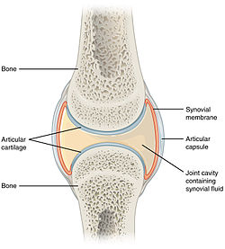

Figure 1: Joint anatomy

Most joints are synovial=freely moving articulations with cartilage covering ends of bones which are enclosed by a fibrous capsule. A synovial membrane lines the joint and secretes serous lubricating synovial fluid.

**Changes during development:**

Fetal development of skeletal system: Embryonic connective tissue->cartilage-> calcifies->eventually becomes bone.

Infants and Children: Ligaments are stronger than bone so injuries to bones and joints are more likely fractures than sprains.

Adolescents: Rapid growth results in decreased strength and flexibility. Bone growth is complete around age of 20. Peak bone mass is achieved at age 35. 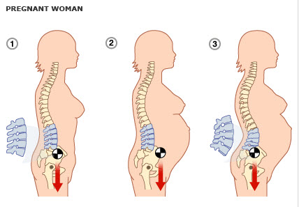

Figure 2: Spine changes in pregnancy

Pregnant: Increased hormones->increased elasticity of ligaments and softening of cartilage in pelvis->increased mobility in pelvic region. Increased fetal growth causes lordosis (inward curvature of lower spine) to help shift center of gravity back over the lower extremities. Low back pain is common.

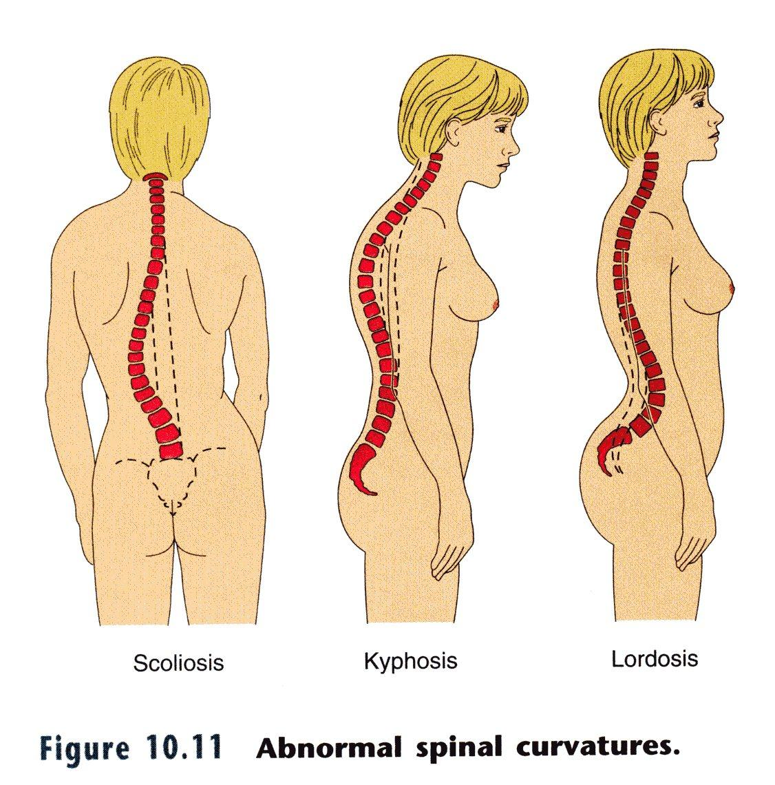Older adults: Aging-> greater resorption of bone than deposition. Increased bone resorption in menopausal women due to decrease in estrogen levels in all bones but vertebrae and long bones are most vulnerable.. Other changes include: decreased elasticity in tendons and decreased total muscle, tone and strength.

Figure 3: Abnormal spinal curvatures

**Physical Examination:**

1. Inspection:
   1. Inspect anterior, posterior and lateral aspects of patient’s posture. Note any lordosis, kyphosis (over-curvature of thoracic vertebrae) or scoliosis (lateral curvature of spine)
   2. Observe symmetry of body parts and alignment of extremities (length, circumference)
   3. Inspect skin overlying muscle, cartilage, bones and joints for any discoloration, swelling or masses
2. Palpation:
   1. Palpate joints including shoulders, elbows, wrist, hands, spine (cervical, thoracic and lumbar), hips, knees, feet and ankles
   2. Note any heat, tenderness, swelling, crepitus (crackling/popping which can be noted when two irregular bones rub together)
   3. No discomfort should occur when applying pressure to bones and joints
   4. Palpate inflamed joints last
3. Range of motion (ROM) and muscle tone:
   1. Examine both active (patient moving joint on his/her own) and passive (physician moving patient’s joints) range of motion for joints listed above
   2. Note any abnormalities such as pain, limitations of motions, spastic movement, joint instability, deformity, and contracture suggestive of problems with the joint or related muscle or nerve supply *Passive ROM: have patient relax and passively range the joint until the end is felt. Do not force the joint if patient has pain or muscle spasm
   3. Discrepancies between active and passive ROM may indicate true muscle weakness or joint disorder
   4. No crepitus or tenderness should occur with movement
4. Muscle strength: considered part of neuro exam but should be done to fully assess a joint
   1. Have patient contract a specific muscle by extending or flexing joint and then resist as you apply force against that muscle contraction. Then, have the patient push against your hand to assess resistance.
   2. Compare strength bilaterally (should be symmetric)

|  |  |
| --- | --- |
| **Assessing Muscle Strength** | |
| **Muscle Function Level** | **Grade** |
| No evidence of movement | 0 |
| Trace movement | 1 |
| Full range of motion but not against gravity | 2 |
| Full range of motion against gravity but not against resistance | 3 |
| Full range of motion against gravity, full resistance | 5 |

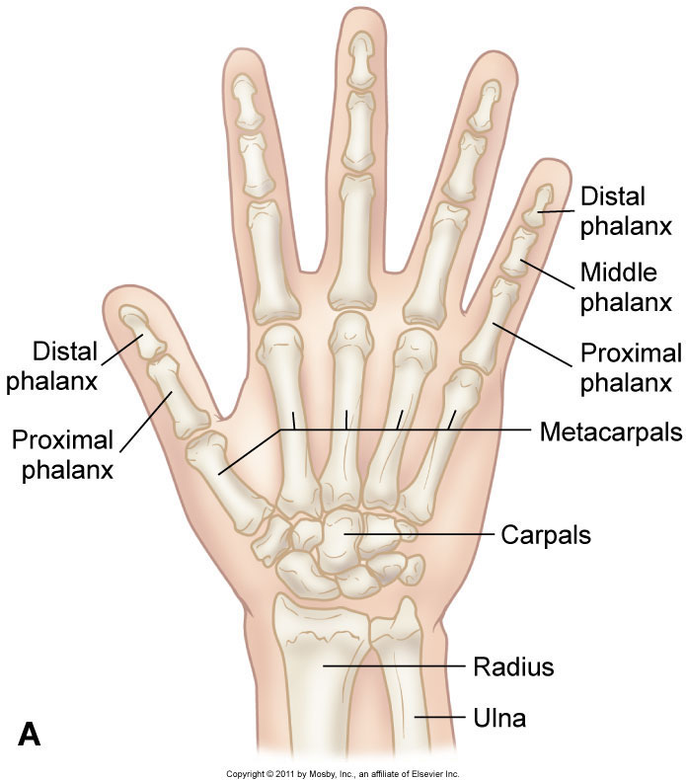**Hands and Wrists:**

Figure 4: Bones of the hand

Anatomy:

1. Wrist: Radiocarpal joint (articulation of radius and carpal bones). An articulation disc separates ulna and carpal bones. Wrist moves in two planes (i.e. flexion/extension and radial/ulnar deviation)
2. Hand: Articulations between:
   1. Carpals and metacarpals
   2. Metacarpals and proximal phalanges
   3. Middle and distal phalanges 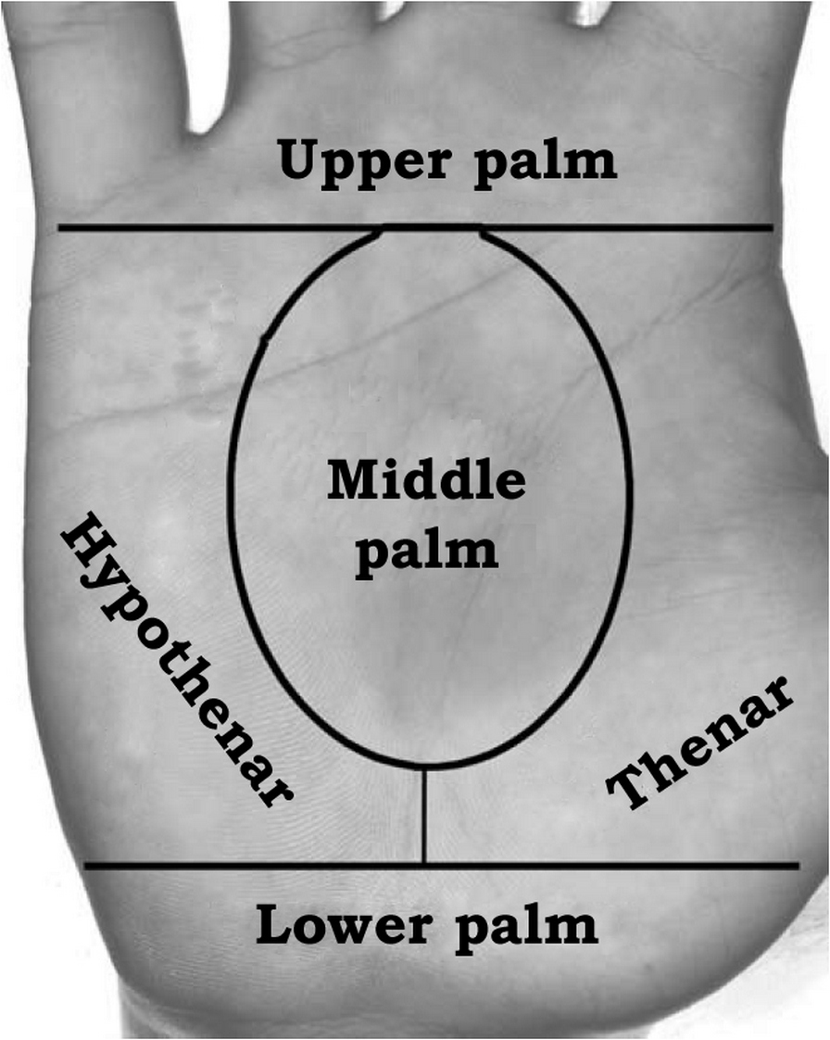
3. Forearm joints: Between radius and ulna at both proximal and distal end (allows for pronation and supination)

*Inspection*: Inspect the dorsal and palmar surfaces. The palmer surface should have prominent, rounded mound (thenar eminence) on the thumb side and a less prominent hypothenar eminence on the little finger side of the hand.

Figure 5: Descriptive locations on the palm

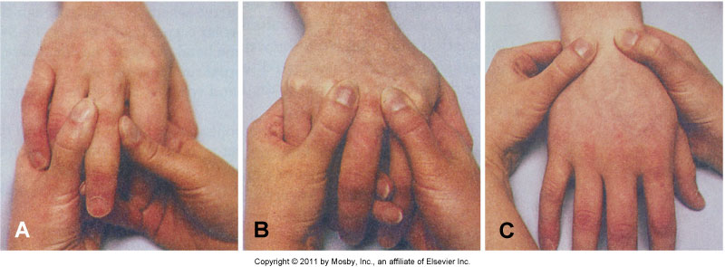*Palpation:* Palpate the wrist and radiocarpal groove with your thumb on the dorsal surface and your fingers on the palmar aspect of the wrist.

Figure 6: Maneuvers for examining joint of the hand and wrist

Palpate interphalangeal joints with your thumb and index finger.

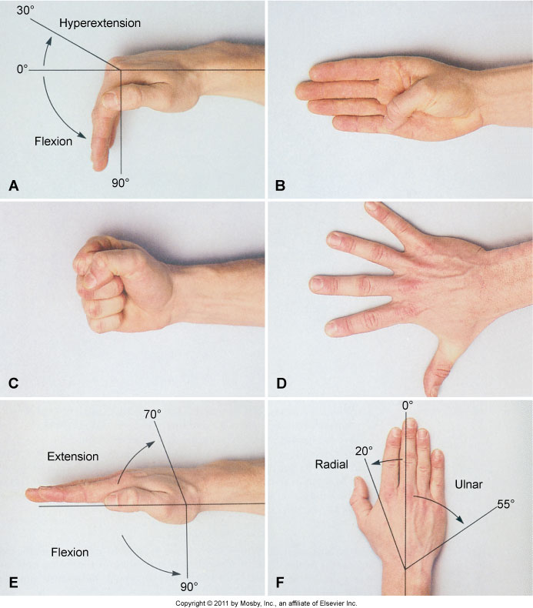

Figure 7: Assessing ROM and strength of the hand

*Examine ROM of hand and wrist by:*

1. Bend fingers forward at metacarpophalangeal joint, and stretching fingers up and back at knuckle. Normal: 90 degrees of flexion and 30 degrees of hyperextension at the metacarpophalangeal joint.
2. Patient should be able to touch thumb to each fingertip, base of little finger and make a complete fist.
3. Have patient spread fingers and then touch them together
4. Have patient flex and extend wrist (should be able to move 90 degrees and 70 degrees, respectively).
5. Have patient start with palm down and then have him or her turn thumb down (radial motion, normal is 20 degrees) and then little finger down (ulnar movement, normal is 55 degrees)

*Examining strength of wrist:*

1. Have patient maintain wrist flexion and then hyperextension while you apply opposing force. 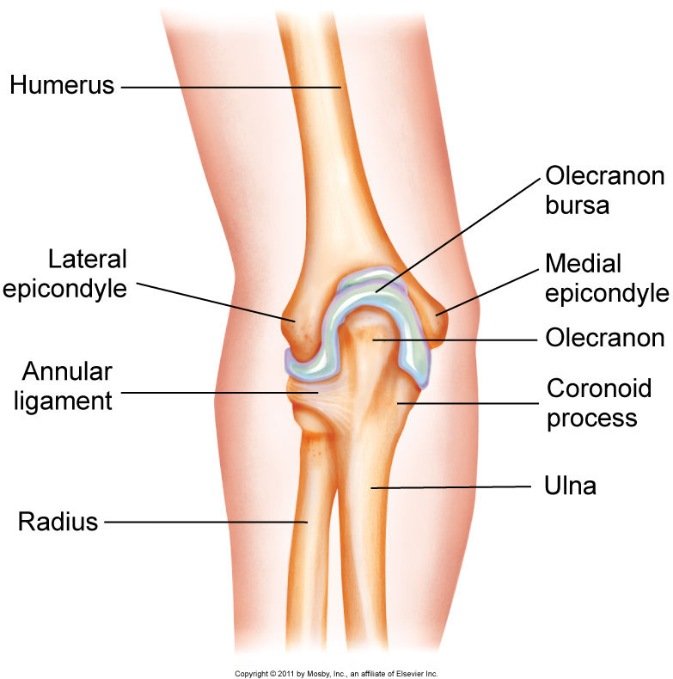

Figure 8: Basic elbow anatomy

*Examining strength of hand:*

1. Have patient tightly grip two of your fingers.

**Elbow:**

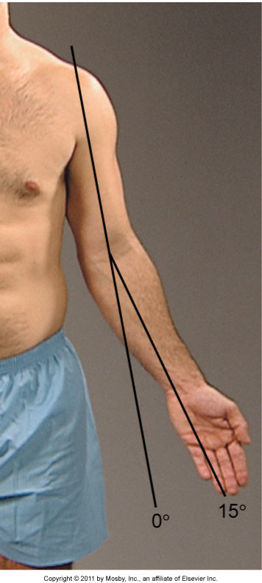*Anatomy:* Articulation between humerus, radius and ulna; all enclosed in a single synovial cavity. Considered a hinge joint with movement of humerus and ulna in one plane for flexion/extension

Figure 9: Normal elbow angle

*Physical examination:*

Inspect elbow in both flexed and extended position.

Note any deviation of the in the angle between humerus and radius while arm is extended (normal is up to 15 degrees laterally). Greater than 15 degrees is called cubitus valgus while cubitus varus is a medial carrying angle

*Palpation:*

1. Flex elbow to 70 degrees and palpate the lateral and medial portions of the distal humerus along with the olecranon process of ulna for any tenderness or pain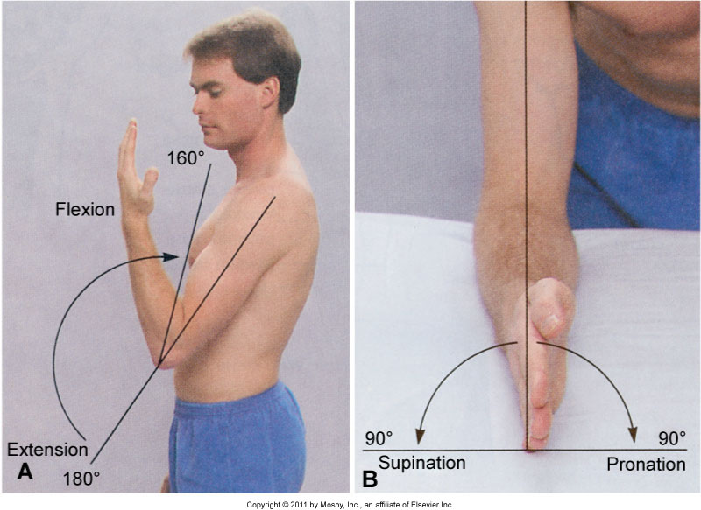

Figure 10: Assessing ROM of elbow

*Examine ROM:*

1. Flex and extend patient's elbow (normal is fully extended or 0 degrees and flexed is 160 degrees)
2. Then have patient flex elbow to 90 degrees with thumb up and have patient rotate hand from palm up to palm facing down (normal is 90 degrees each way)

*Strength:*

1. Have patient maintain flexion and extension while applying opposing force.

**Shoulder:**

*Anatomy:*

1. 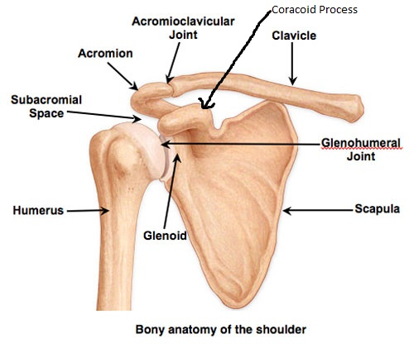Glenohumeral joint is a ball and socket joint. There is an articulation between humerus and glenoid fossa of scapula. The acromion and coracoid process of scapula form an arch and protect the joint.

Figure : Bony anatomy of the shoulder

1. Additional joints of shoulder girdle adjacent to glenohumeral joint
   1. Acromioclavicular joint: between acromion process and clavicle
   2. Sternoclavicular joint: articulation between sternum and clavicle

*Physical Examination:*

*Inspection:*

1. Inspect the contour and symmetry of the shoulder, clavicles, scapula and surrounding muscles

*Palpation:*

1. Palpate the sternoclavicular joint, clavicle, scapula, coracoid process, proximal humerus and nearby muscles.

*ROM:*

1. Ask patient to perform the following actions from a relaxed position:
   1. 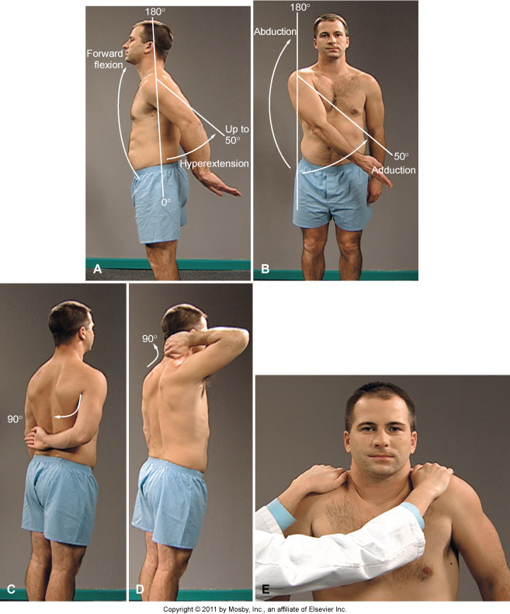Shrug shoulders
   2. Raise both arms forward and straight up over the head (normal is 180 degrees)
   3. Extend and stretch both arms behind back (normal is 50 degrees)
   4. Lift both arms out laterally and over the head (normal is 180 degrees)
   5. Adduct arm: bring arm across the front of body (normal is 50 degrees)
   6. Place arms behind hips and then arms behind head, both with elbows out, to assess internal and external rotation respectively. (Normal is 90 degrees)

*Strength*

1. Have patient shrug shoulders while applying opposing force down (assessment of strength and cranial nerve 11)

Figure 12: Assessing ROM and strength of shoulder

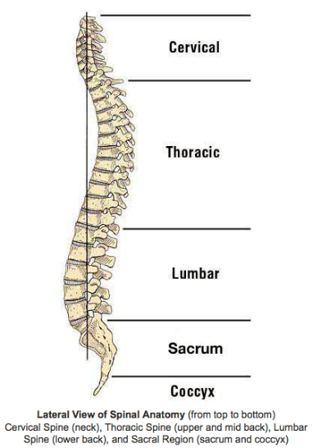

**Spine:**

*Anatomy:* Composed of cervical, thoracic, lumbar and sacral vertebrae. All are separated by fibrocartilaginous discs except the sacral vertebrae (which are fused)

Cervical spine: most flexible with flexion/extension between skull and C1 and rotation between C1 and C2

*Inspect:*

1. Inspect neck from both anterior and posterior view and its relation to shoulders. (Normal: concave when head is erect)

*Palpate:*

Figure 13: Lateral view of spinal anatomy

1. 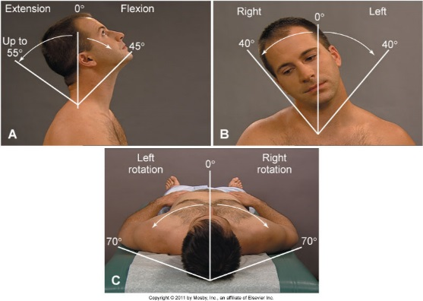Posterior neck, cervical spine, and paravertebral, trapezius and sternocleidomastoid muscles.

Figure 14: Assessing ROM of the neck

*ROM:* Ask patient to:

1. Bend the head forward with chin to chest
2. Bend head backward (normal is 45 degrees)
3. Bend head to the side with ear to each shoulder (normal is 40 degrees)
4. Turn head to side, with chin to each shoulder (normal is 70 degrees)

*Strength:*

Have patient turn head to side while you place an opposing force.

Thoracic and Lumbar spine (the most prominent spinous process is C7, below starts the thoracic vertebrae)

*Inspection:*

1. Thoracic spine should be convex (kyphosis is an exaggerated curvature) and lumbar spine should be concave (lordosis is exaggerated curvature)
2. 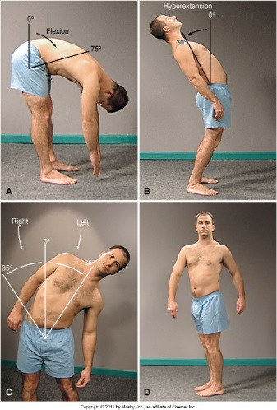Have patient bend forward and touch toes while you observe from behind. Look for any unexpected curvature of spine including lateral curvature (scoliosis)

*Palpate:*

1. Along the spinal processes and paravertebral muscles (normal includes no muscle spasm or spinal tenderness)

*ROM:*

Ask patient to:

1. Bend forward at waist without bending knees. Normal flexion is 75-90 degrees
2. Bend back at the waist. Normal hyperextension is 30 degrees
3. Bend to each side while keeping body faced forward. Normal lateral bend is 35 degrees.
4. Rotate core while stabilizing pelvis. Normal is 30 degrees.

Figure 15: Assessing ROM of the spine

**Hips**: ball and socket joint

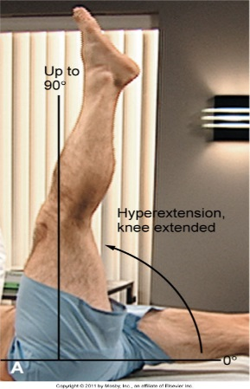Anatomy: articulation between acetabulum of pelvis and femur

*Inspection:*

1. Inspect anteriorly and posteriorly while patient stands
2. Look for any asymmetry in iliac crest height and size of buttocks

*ROM: Have patient perform the following tasks:*

1. While supine, raise leg with knee extended above body (normal is 90 degree hip flexion)
2. While supine, raise knee to chest while keeping other leg straight. Then switch sides (normal is 120 degrees of hip flexion)

Figure 16: Assessing hip flexion

1. 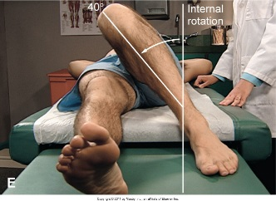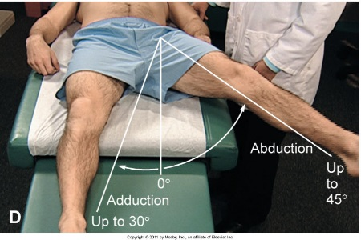While supine, swing straight leg laterally and medially (normal is 40 degrees of abduction and 30 degrees adduction)

Figure 17: Assessing abduction and adduction of the hip

1. While supine, flex knee of one leg while keeping foot on table and rotate leg toward the straight leg to measure internal rotation

Figure 18: Assessing internal rotation of the hip

(normal is 40 degrees)

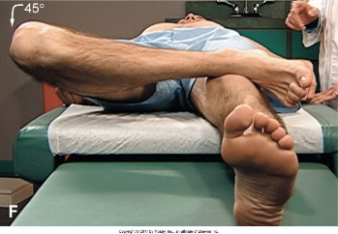

Figure 19: Assessing external rotation of the hip

1. 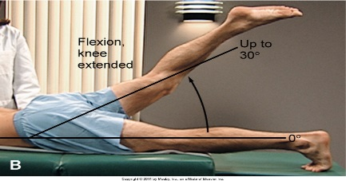While supine, place lateral aspect of foot on knee of other leg and move flexed knee toward table to measure external rotation (normal is 45 degrees)

Figure : Assessing hip extension

1. While standing or prone, swing straight leg behind body without arching back (normal 30 degrees)

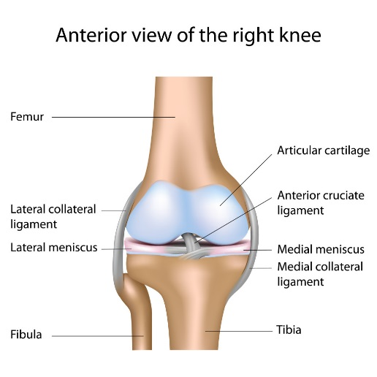**Legs and knees:**

*Anatomy:*

1. Articulation of femur, tibia, and patella; hinge joint between femur and tibia allowing flexion/extension (one plane)
2. Medial and lateral menisci (fibrocartilaginous discs acting as a cushion between tibia and femur)
3. Collateral ligaments give medial and lateral stability along with cruciate ligaments for anterior and posterior stability (ACL and PCL)

Figure 21: Anterior view of the right knee

*Inspection:*

1. 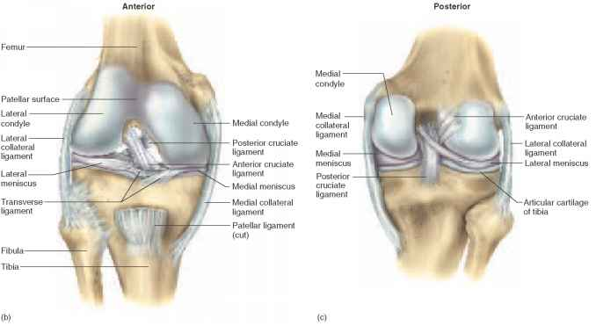Inspect knees in both flexed and extended positions. In extended position, there should be concavities on each side of patella (knee effusions could cause loss of concavities).
2. Angle between femur and tibia should be less than 15 degrees (variations: genu valgum aka knock knees and genu varum aka bowlegs)

Figure : Ligaments of the knee

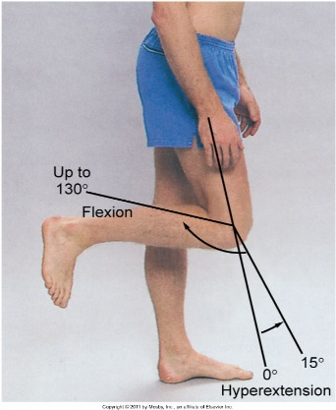*Palpate:*

1. Palpate popliteal space for any swelling or tenderness (fullness could indicate cyst)
2. Palpate tibiofemoral joint and patella (should be smooth without tenderness or crepitus)

*ROM: Ask patient to:*

1. Bend each knee (normal is 130 degrees)
2. Straighten leg (full extension up to 15 degrees hyperextension)

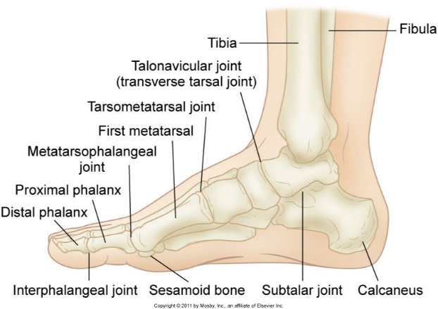**Feet and Ankeles:**

Figure 23: Assessing ROM of the knee

Figure 24: Basic anatomy of the foot

*Anatomy:*

1. Ankle (tibiotalar joint)- articulation of tibia, fibula and talus; hinge joint allowing dorsiflexion (top of foot upwards) and plantar flexion (bottom of foot downward)
2. Foot: Articulations between tarsals and metatarsals, metatarsals and proximal phalanges, and middle and dorsal phalanges, all allowing for flexion/extension

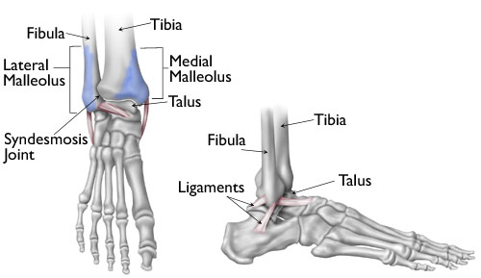*Inspection:*

Figure 25: Bones of the foot

1. Inspect while patient is bearing weight (standing/walking) and sitting
2. Landmarks include medial malleolus, lateral malleolus and Achilles tendon
3. Feet should be in alignment with tibias (variations include pes varus aka “in-toeing” and pes valgus aka “out-toeing”)
4. Examine arch (variations include pes planus aka flat feet and pes cavus aka high arch)
5. Note any hyperextension of toes or lateral deviation of great toe (hallux valgus aka bunion)
6. Inflamed metatarsophalangeal joint of great toe should raise suspicion of gout

*Palpate:*

1. Achilles tendon, anterior surface of ankle, and medial and lateral malleoli
2. Use thumb and fingers of both hands to palpate each metatarsophalangeal joing

*ROM:*

1. 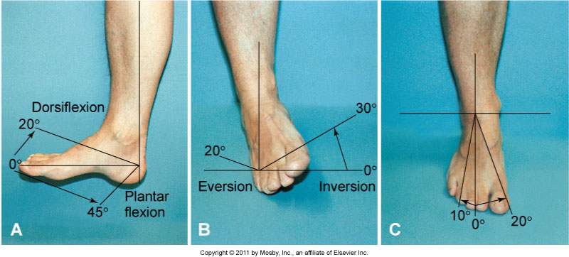Point foot toward ceiling (normal dorsiflexion of 20 degrees)

Figure 26: Assessing ROM of the ankle

1. Point foot toward the floor (normal plantar flexion of 45 degrees)
2. Turn sole of foot toward and then away from the other foot (normal inversion of 30 degrees and eversion of 20 degrees)
3. Turn foot away from and then toward other foot (normal abduction of 10 degrees and adduction of 20 degrees)
4. Bend and straighten toes

*Strength:*

1. Have patient maintain dorsiflexion and plantar flexion while you apply opposing force

Pertinent topics to cover during history taking:

|  |  |
| --- | --- |
| Chief Complaint | Topics to Cover with Patient |
| Joint Symptoms | -Character: stiffness, limitations to movement, change in size, swelling, redness, constant vs pain with movement, unilateral vs bilateral, interference with daily activities  -Associated events: time of day, activity, specific movements, injury, weather  -Temporal factors: change in frequency or character of episodes, increase or decrease in pain as day progresses, sudden vs insidious onset  -Efforts to treat: exercise, rest, weight reduction, physical therapy, heat, ice, brace  -Medications: NSAIDs, acetaminophen, immunosuppressants, steroids, topical cream, glucosamine |
| Muscular symptoms | -Character: limitation of movement, weakness, paralysis, tremor, spasm, clumsiness, muscle wasting, type of pain  -Precipitating factors: injury, strenuous activity, sudden movement, stress  -Efforts to treat: heat, ice, rest, massage  -Meds: muscle relaxant, statin, aspirin, NSAIDs |
| Skeletal symptoms | -Character: difficulty with gait/limping, numbness, tingling, pain with movement, crepitus, deformity  -Associated event: injury, fracture, strenuous activity, sudden movement, stress, postmenopausal  -Efforts to treat: rest, splint, chiropractic, acupuncture  -Medications: hormone therapy, calcium, calcitonin, bisphosphonates. |
| Injury | -Sensation at time of injury: click, pop, tearing, numbness, tingling, snapping, warmth, ability to bear weight  -Mechanism of injury: trauma, overuse, change in direction, overstretch  -Pain: location, type, sudden vs gradual, aggravating/alleviating factors  -Efforts to treat: rest, ice, heat, splint  Meds: analgesics, anti-inflammatory |
| Back pain | -Abrupt vs gradual  -Character: type of pain, location, numbness/tingling, radiation to buttocks, groin or legs.  -Associated event: trauma, lifting heavy object, long drive, sports, change in posture  -Efforts to treat: rest, avoid standing, chiropractic, acupuncture  -Medications: muscle relaxants, analgesics, anti-inflammatory |